Directorate of placement & counselling

SI.No. | Name | Designation | Department | College | Aadhar No. | Email id | Mobile no. | Photo
01 | Dr. Mahendra Singh Negi | Director | Directorate of placement & counselling | Directorate of placement & counselling | 327318046854 | drmsnegi22@gmail.com | 9412370194 | 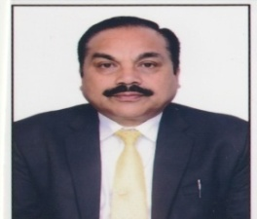
02 | Dr. Geeta pathak | Associate Director | Directorate of placement & counselling | Directorate of placement & counselling | 585012245752 | pathakgita28@gmail.com | 9719348559 | 